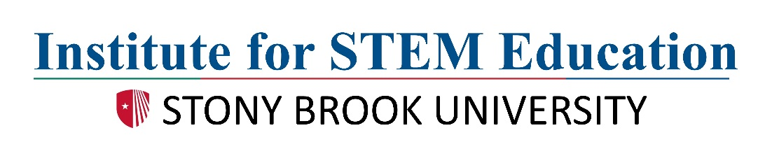

Explorations in Forensics
Application for Summer 2018

The deadline for this application is March 30, 2018. Arrange to have two teachers complete the enclosed recommendation forms; these letters should be sent directly to the address below. In addition, please include a copy of your high school transcript.

Name _________________________________________________________________________
last first middle

Mailing Address _________________________________________________________________________
street and apt. number

_________________________________________________________________________
city state zip code

Gender _________________________

Phone # _______________________ Career Goal ____________________

High School _______________________ Year of Graduation _________________
Date of Birth _______________________ T-shirt Size ________________________

E-mail address _____________________________ Parent email address ________________

Letters of recommendation (to be sent directly from teacher) will be coming from:

Name of teacher ____________________________________________

Name of teacher ____________________________________________

Applications must be postmarked by March 30, 2018 and sent directly to:

Institute for STEM Education
092 Life Sciences Building
Stony Brook University
Stony Brook, NY 11794-5233
Telephone: 631-632-9750
Fax: 631-632-9791
istem@stonybrook.edu

Explorations in Forensics Program
Teacher Recommendation Form
(To be completed by any teacher who has taught you.)

Student’s Name

Teacher’s Name School

Capacity in which you know this student

Please compare this student to the others that you have taught:

 | Top 2% | Top 10% | Top 25% | Top 50% | Less than 50%
Maturity
Positive interaction with peers
Inquisitiveness
Ability to complete tasks
Student’s strengths:

Student’s weaknesses:

Additional comments:

Teacher’s signature Date
Deadline: 03/30/18
Please send to: Institute for STEM Education, 092 Life Sciences Building, Stony Brook University, Stony Brook, NY 11794-5233 (tel: 631-632-9750; fax: 631-632-9791)

Explorations in Forensics Program
Teacher Recommendation Form
(To be completed by any teacher who has taught you.)

Student’s Name

Teacher’s Name School

Capacity in which you know this student

Please compare this student to the others that you have taught:

 | Top 2% | Top 10% | Top 25% | Top 50% | Less than 50%
Maturity
Positive interaction with peers
Inquisitiveness
Ability to complete tasks
Student’s strengths:

Student’s weaknesses:

Additional comments:

Teacher’s signature Date
Deadline: 03/30/18
Please send to: Institute for STEM Education, 092 Life Sciences Building, Stony Brook University, Stony Brook, NY 11794-5233 (tel: 631-632-9750; fax: 631-632-9791)

